**DAILY ONLINE ACTIVITIES SUMMARY**

|  |  |  |  |  |  |  |  |  |
| --- | --- | --- | --- | --- | --- | --- | --- | --- |
| **Date:** | **05/06/2020** | | | | | **Name:** | **ANUSH RATNAKAR SHETTY** | |
| **Sem & Sec** | **4&A** | | | | | **USN:** | **4AL18CS008** | |
| **Online Test Summary** | | | | | | | | |
| **Subject** | | **-** | | | | | | |
| **Max. Marks** | | **-** | | **Score** | | | **-** | |
| **Certification Course Summary** | | | | | | | | |
| **Course** | **Game development using PyGame** | | | | | | | |
| **Certificate Provider** | | | **GUVI** | | **Duration** | | | **3 HOURS** |
| **Coding Challenges** | | | | | | | | |
| **Problem Statement1:Write a java program to find duplicate characters in a string** | | | | | | | | |
| **Status:Executed** | | | | | | | | |
| **Uploaded the report in Github** | | | | | **YES** | | | |
| **If yes Repository name** | | | | | **https://github.com/anushshetty30/lockdown-coding** | | | |
| **Uploaded the report in slack** | | | | | **YES** | | | |

Online Test Details1:No test was conducted today

Certification Course Details:”GAME DEVELOPMENT USING PyGame”

Attended a 3 hour game development using pygame course and completed all the assessment which we needed to do in order to obtain the e-certificate.

I successfully completed all the assessments with 95% marks and I have obtained the e-certificate

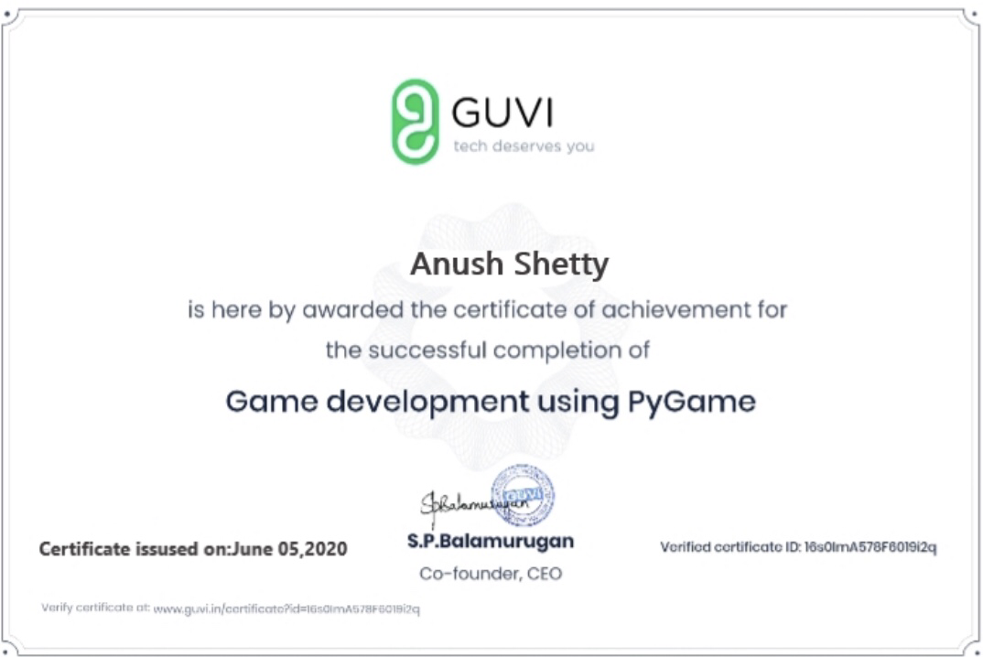

Coding details1:Write a java program to find duplicate characters in a string

